AWS Practical Exam Backup Screenshots
Question 1
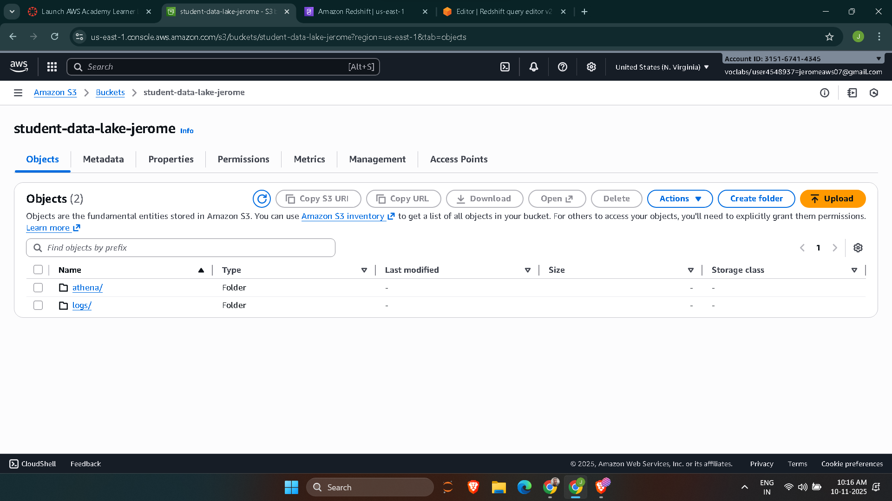

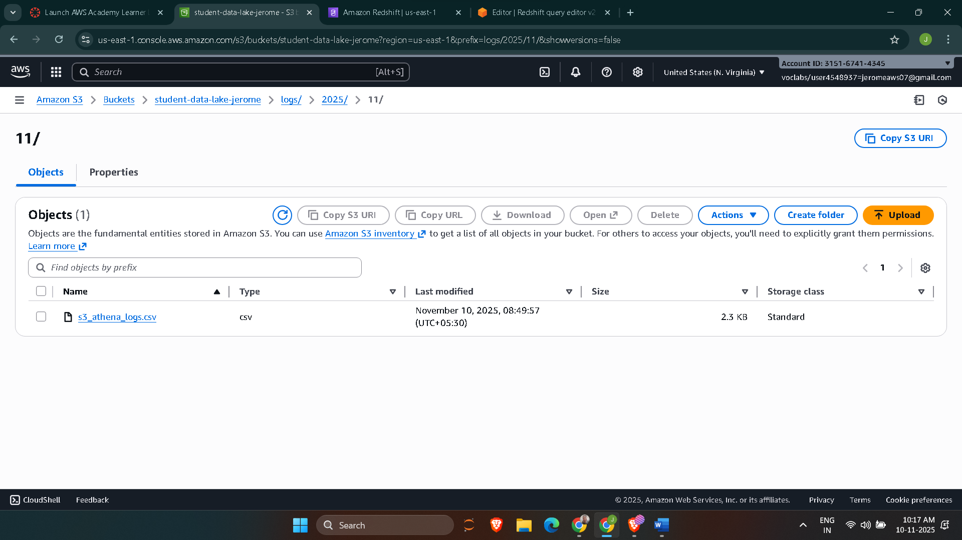

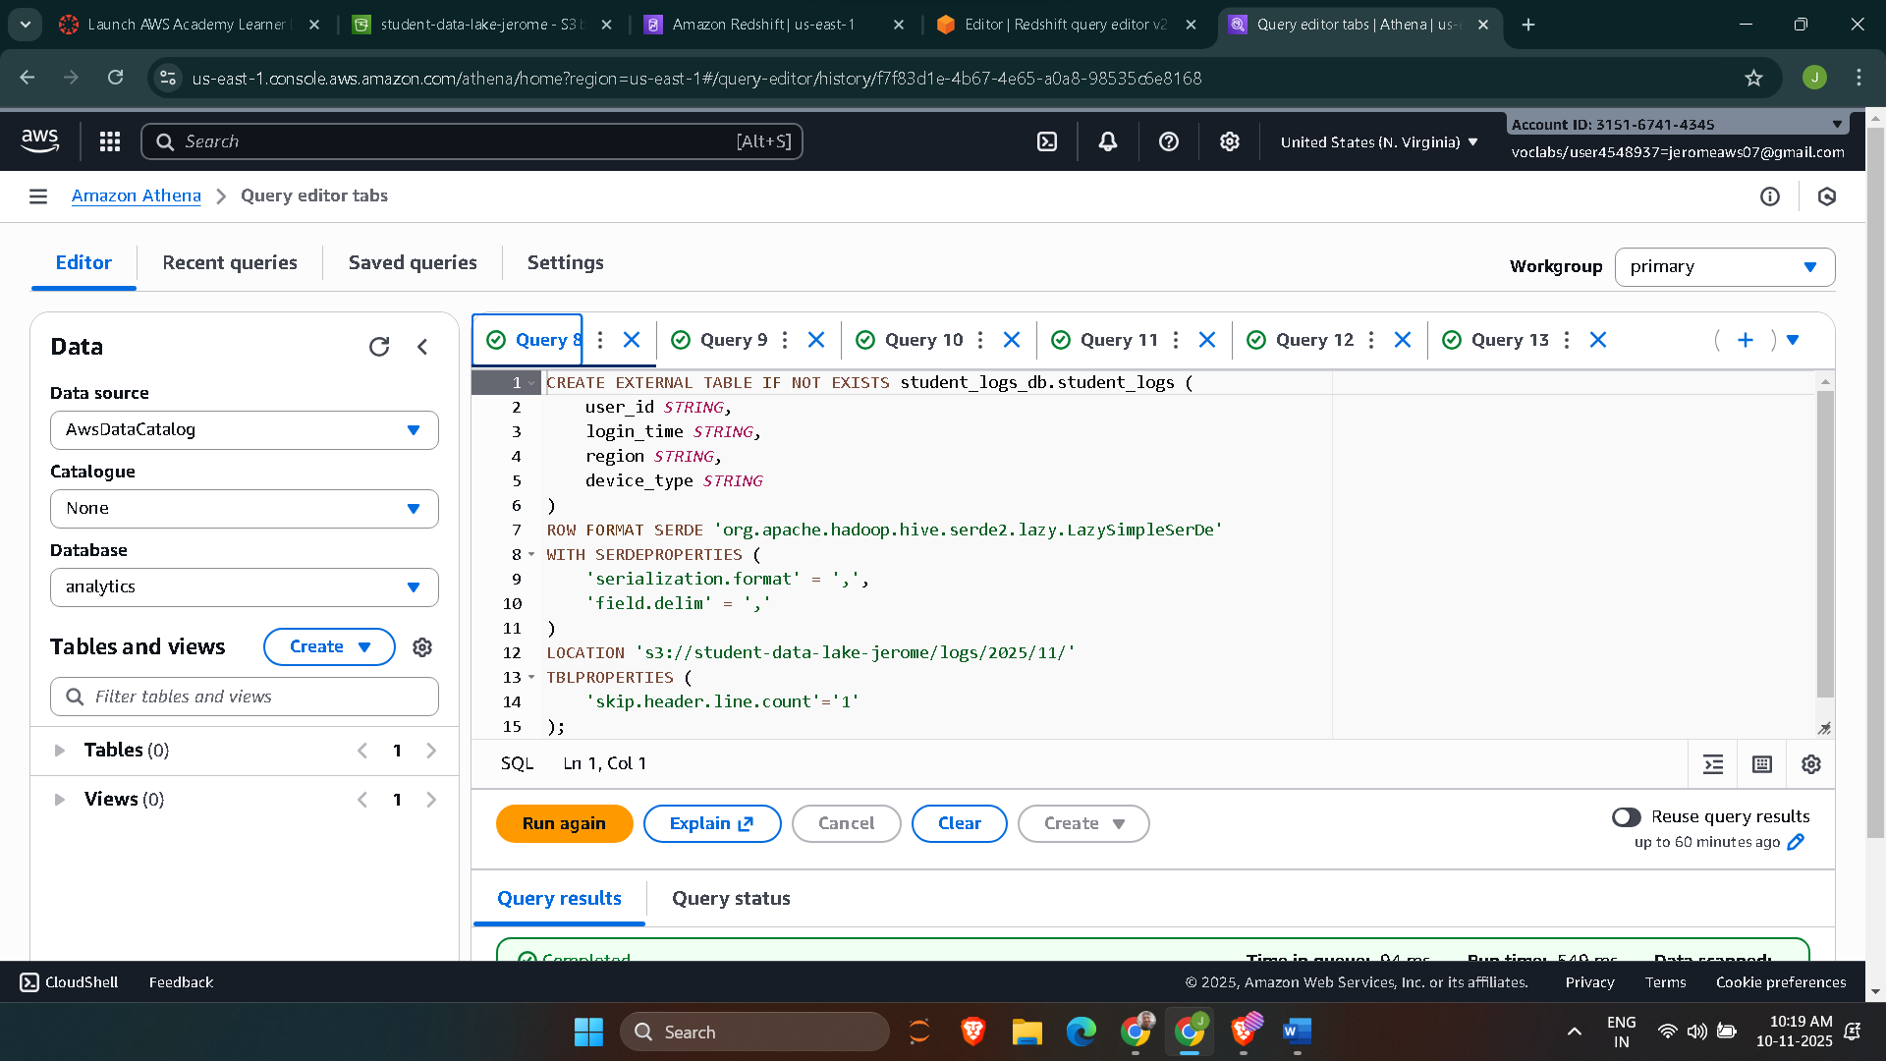

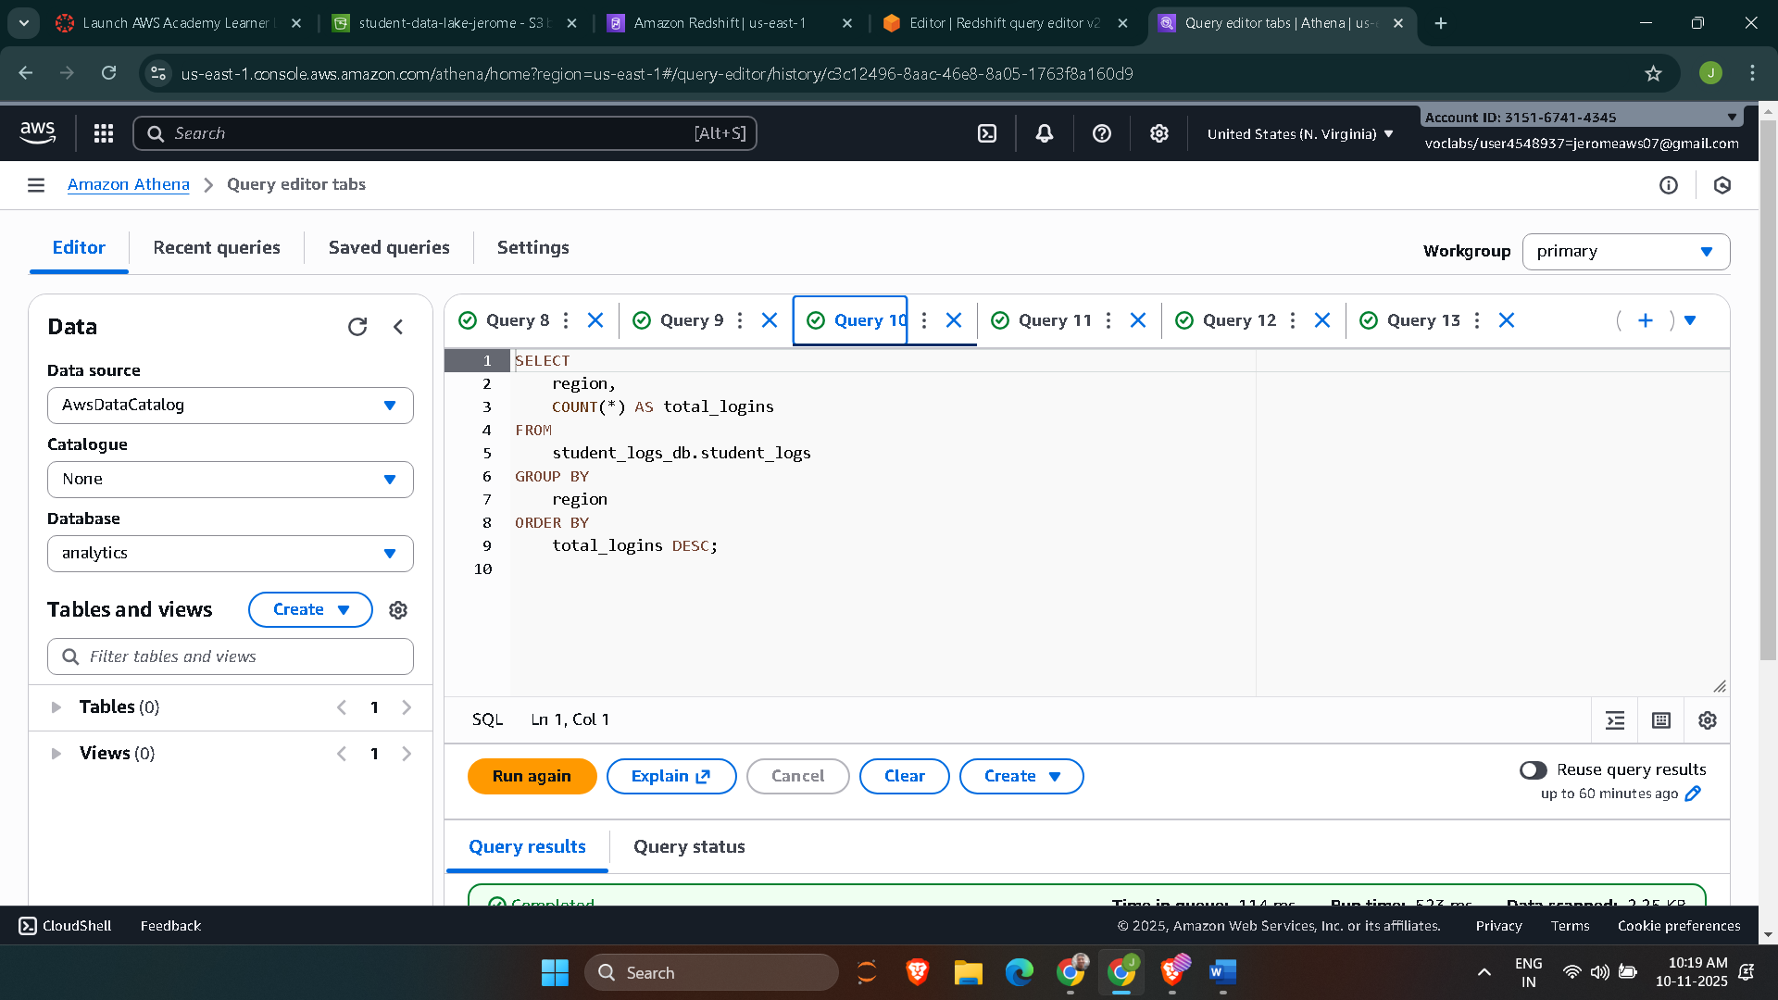

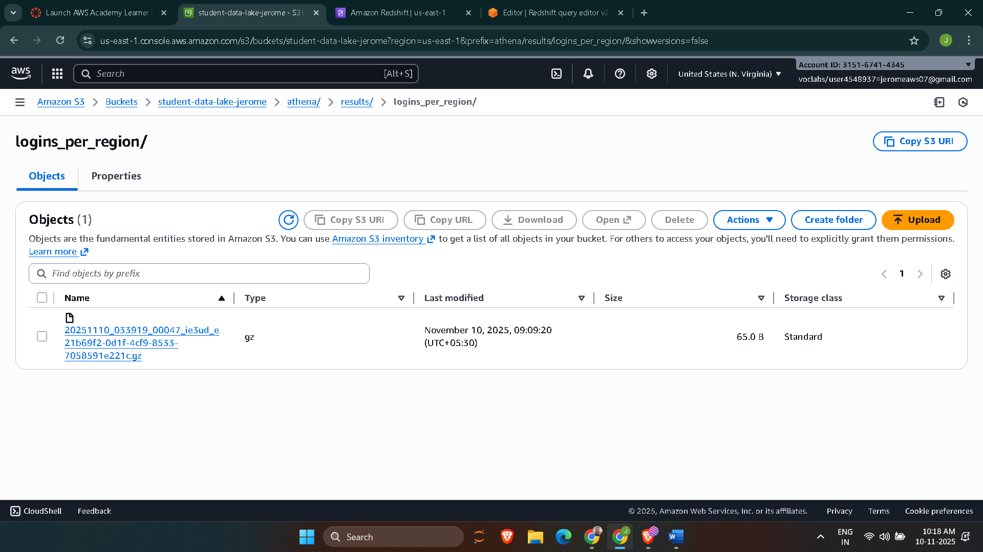

Question-2

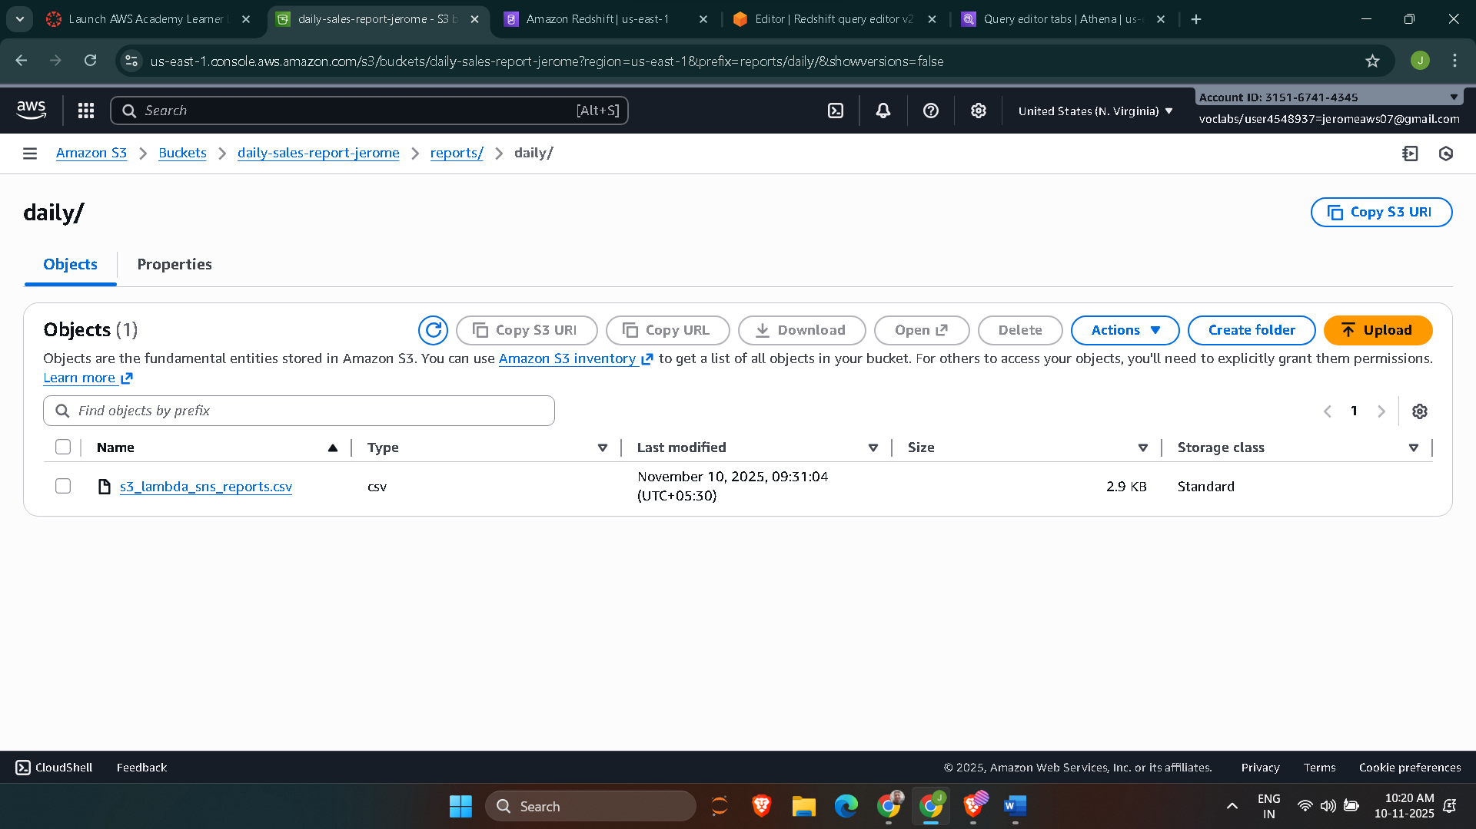

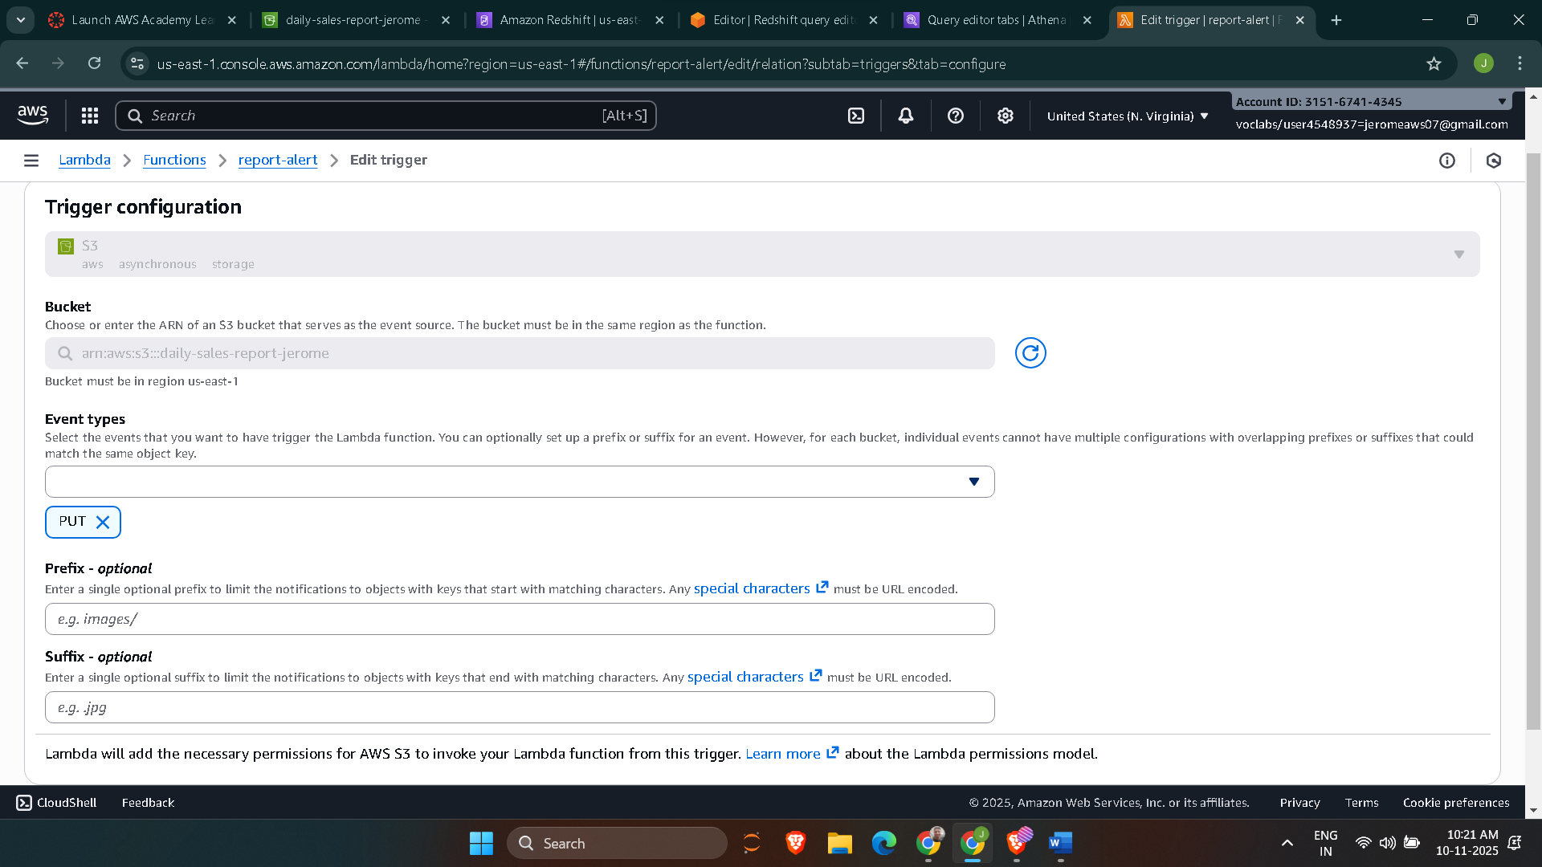

Lambda code
import json
import boto3
from datetime import datetime

# Initialize clients outside the handler for potential performance benefits
s3_client = boto3.client('s3')
sns_client = boto3.client('sns')

# !! IMPORTANT: Replace with your actual SNS Topic ARN !!
# Make sure your Lambda execution role has the 'sns:Publish' permission.
SNS_TOPIC_ARN = 'arn:aws:sns:us-east-1:315167414345:daily-report-alerts' # REPLACE THIS

def lambda_handler(event, context):
processed_files = []

try:
# Ensure the event has records and is a list
if 'Records' not in event or not isinstance(event['Records'], list) or len(event['Records']) == 0:
raise ValueError("No valid records found in the event")

# Iterate over ALL records in the batch
for record in event['Records']:
# Validate that this is indeed an S3 event record
if 's3' not in record:
print("Skipping non-S3 record:", json.dumps(record))
continue

# Extract S3 event details using the correct dictionary keys
bucket = record['s3']['bucket']['name']
key = record['s3']['object']['key']

# Get object metadata
response = s3_client.head_object(Bucket=bucket, Key=key)

metadata = {
'file_name': key,
'file_size': response['ContentLength'],
'upload_time': response['LastModified'].isoformat(),
'bucket': bucket
}

# Publish to SNS
message = json.dumps(metadata, indent=2)
sns_client.publish(
TopicArn=SNS_TOPIC_ARN,
Subject=f'S3 File Upload Alert: {key}',
Message=message
)

processed_files.append(key)

return {
'statusCode': 200,
'body': json.dumps(f'Successfully processed {len(processed_files)} files: {processed_files}')
}

except Exception as e:
print(f"Error processing records: {str(e)}")
# In a real production scenario, you might want to stop processing and raise the error
# so Lambda retries the entire batch.
return {
'statusCode': 500,
'body': json.dumps(f'Error occurred during processing: {str(e)}')
}

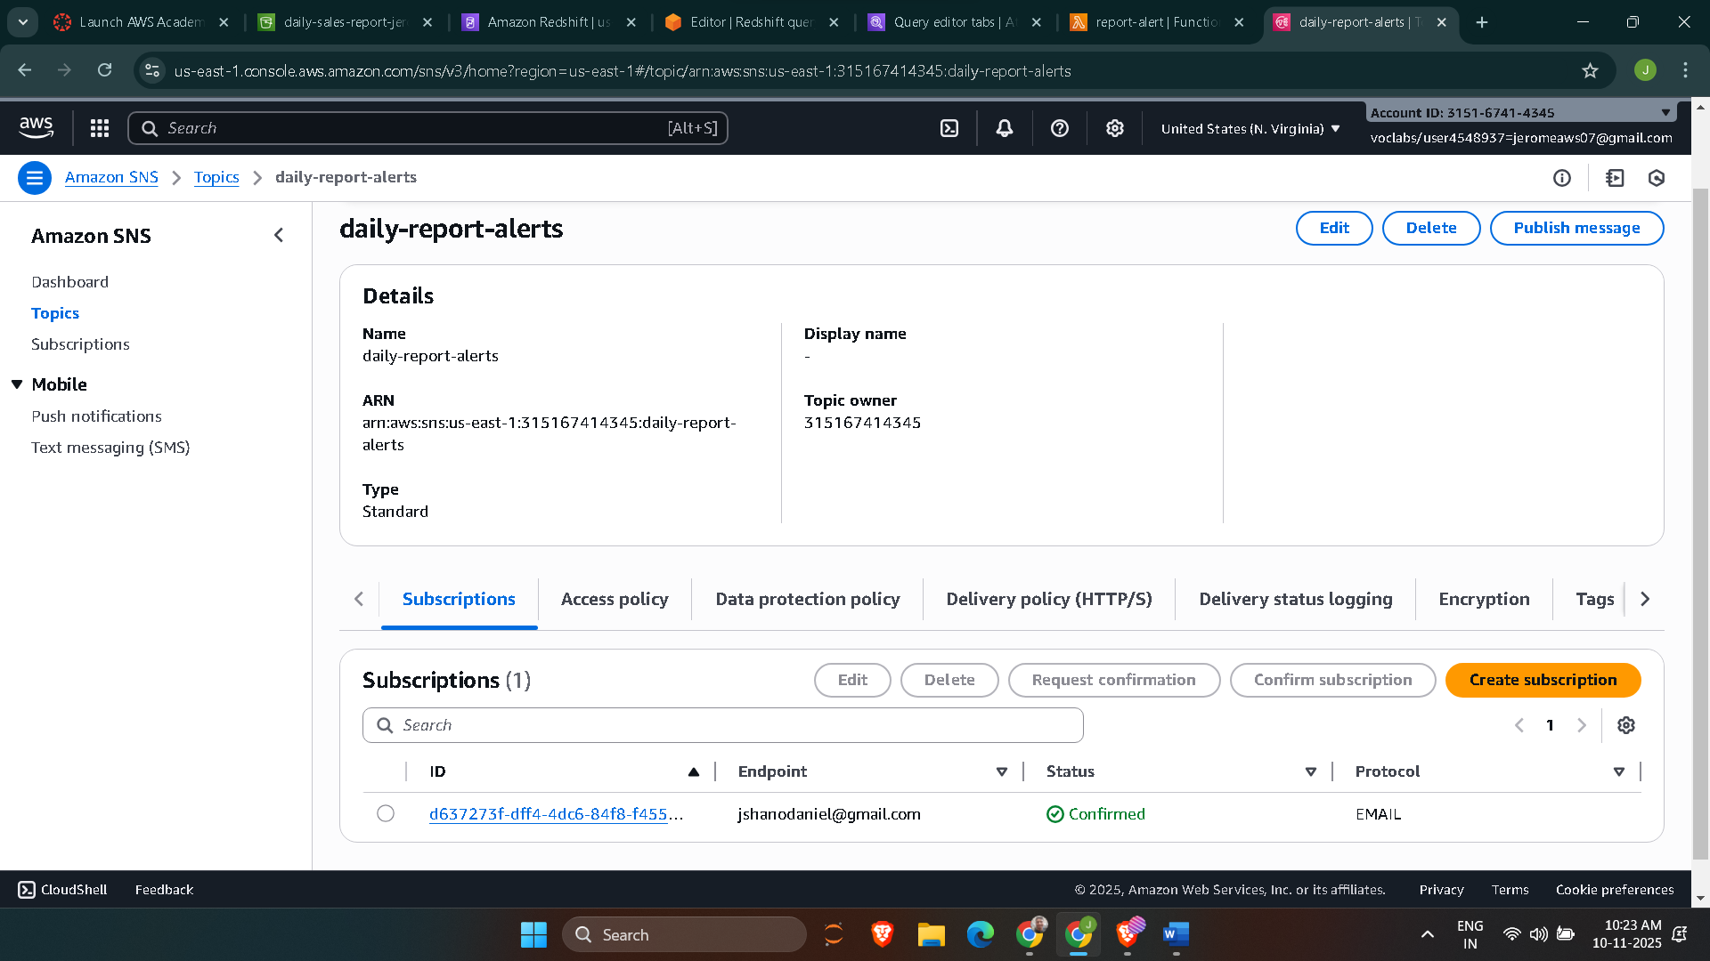

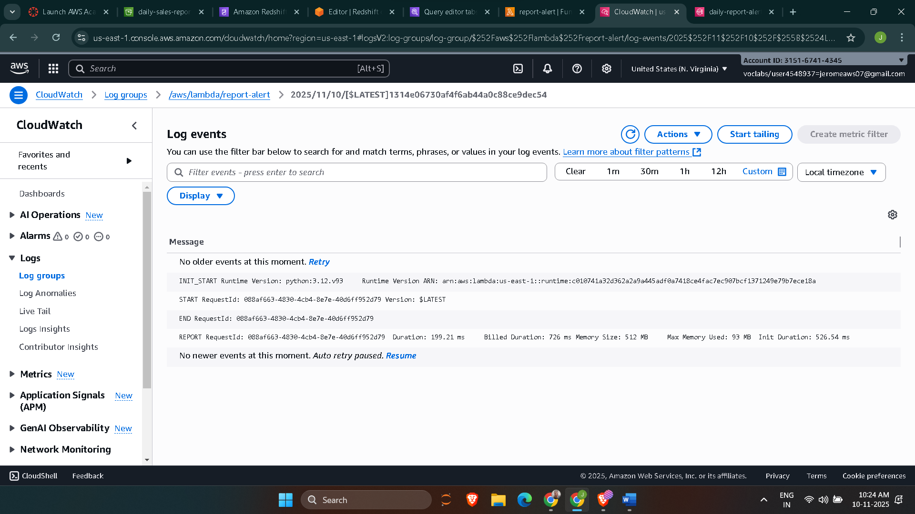

Question-3
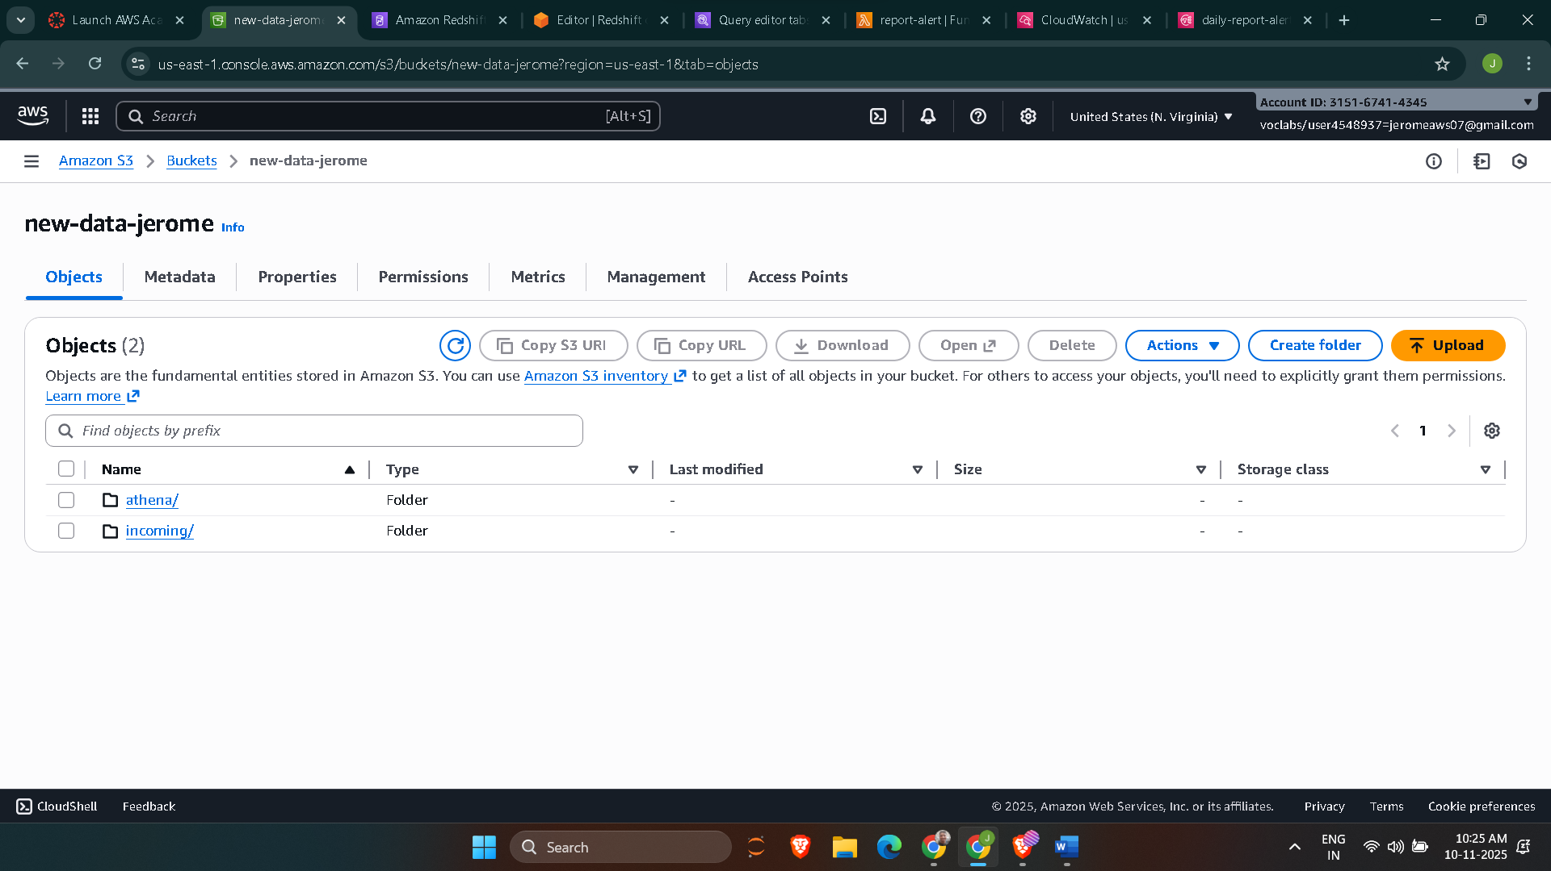

Lambda Code
import boto3
import time
import json

athena = boto3.client("athena")
sns = boto3.client("sns")

# === CONFIGURATION ===
ATHENA_DB = "data_quality_db"
ATHENA_OUTPUT = "s3://new-data-jerome/athena/results/"
SNS_TOPIC_ARN = "arn:aws:sns:us-east-1:315167414345:data-quality-alerts"

def run_athena_query(query: str) -> int:
"""Run Athena query and return the first integer result."""
execution = athena.start_query_execution(
QueryString=query,
QueryExecutionContext={"Database": ATHENA_DB},
ResultConfiguration={"OutputLocation": ATHENA_OUTPUT},
)
qid = execution["QueryExecutionId"]

# Poll until query completes
while True:
result = athena.get_query_execution(QueryExecutionId=qid)
state = result["QueryExecution"]["Status"]["State"]
if state in ("SUCCEEDED", "FAILED", "CANCELLED"):
break
time.sleep(1.5)

if state != "SUCCEEDED":
raise RuntimeError(f"Athena query failed with state: {state}")

# Extract numeric result
res = athena.get_query_results(QueryExecutionId=qid)
rows = res["ResultSet"]["Rows"]
if len(rows) < 2:
return 0
return int(rows[1]["Data"][0]["VarCharValue"])

def lambda_handler(event, context):
try:
record = event["Records"][0]
bucket = record["s3"]["bucket"]["name"]
key = record["s3"]["object"]["key"]
file_path = f"s3://{bucket}/{key}"
print(f"Triggered by upload: {file_path}")

# === ATHENA VALIDATION QUERY ===
query = f"""
SELECT COUNT(*) AS bad_count
FROM {ATHENA_DB}.orders
WHERE order_id IS NULL
OR TRIM(order_id) = ''
OR price < 0
"""

bad_records = run_athena_query(query)
print(f"Bad record count: {bad_records}")

# === ALERT IF BAD DATA FOUND ===
if bad_records > 0:
message = {
"alert_type": "data_quality_violation",
"bad_records": bad_records,
"file": file_path,
"criteria": "Missing order_id or negative price"
}
sns.publish(
TopicArn=SNS_TOPIC_ARN,
Subject="Data Quality Alert - Incoming Orders",
Message=json.dumps(message, indent=2),
)
print("SNS alert sent.")
else:
print("No data quality issues found.")

return {
"statusCode": 200,
"body": json.dumps({"file": file_path, "bad_records": bad_records}),
}

except Exception as exc:
print(f"Error: {exc}")
raise

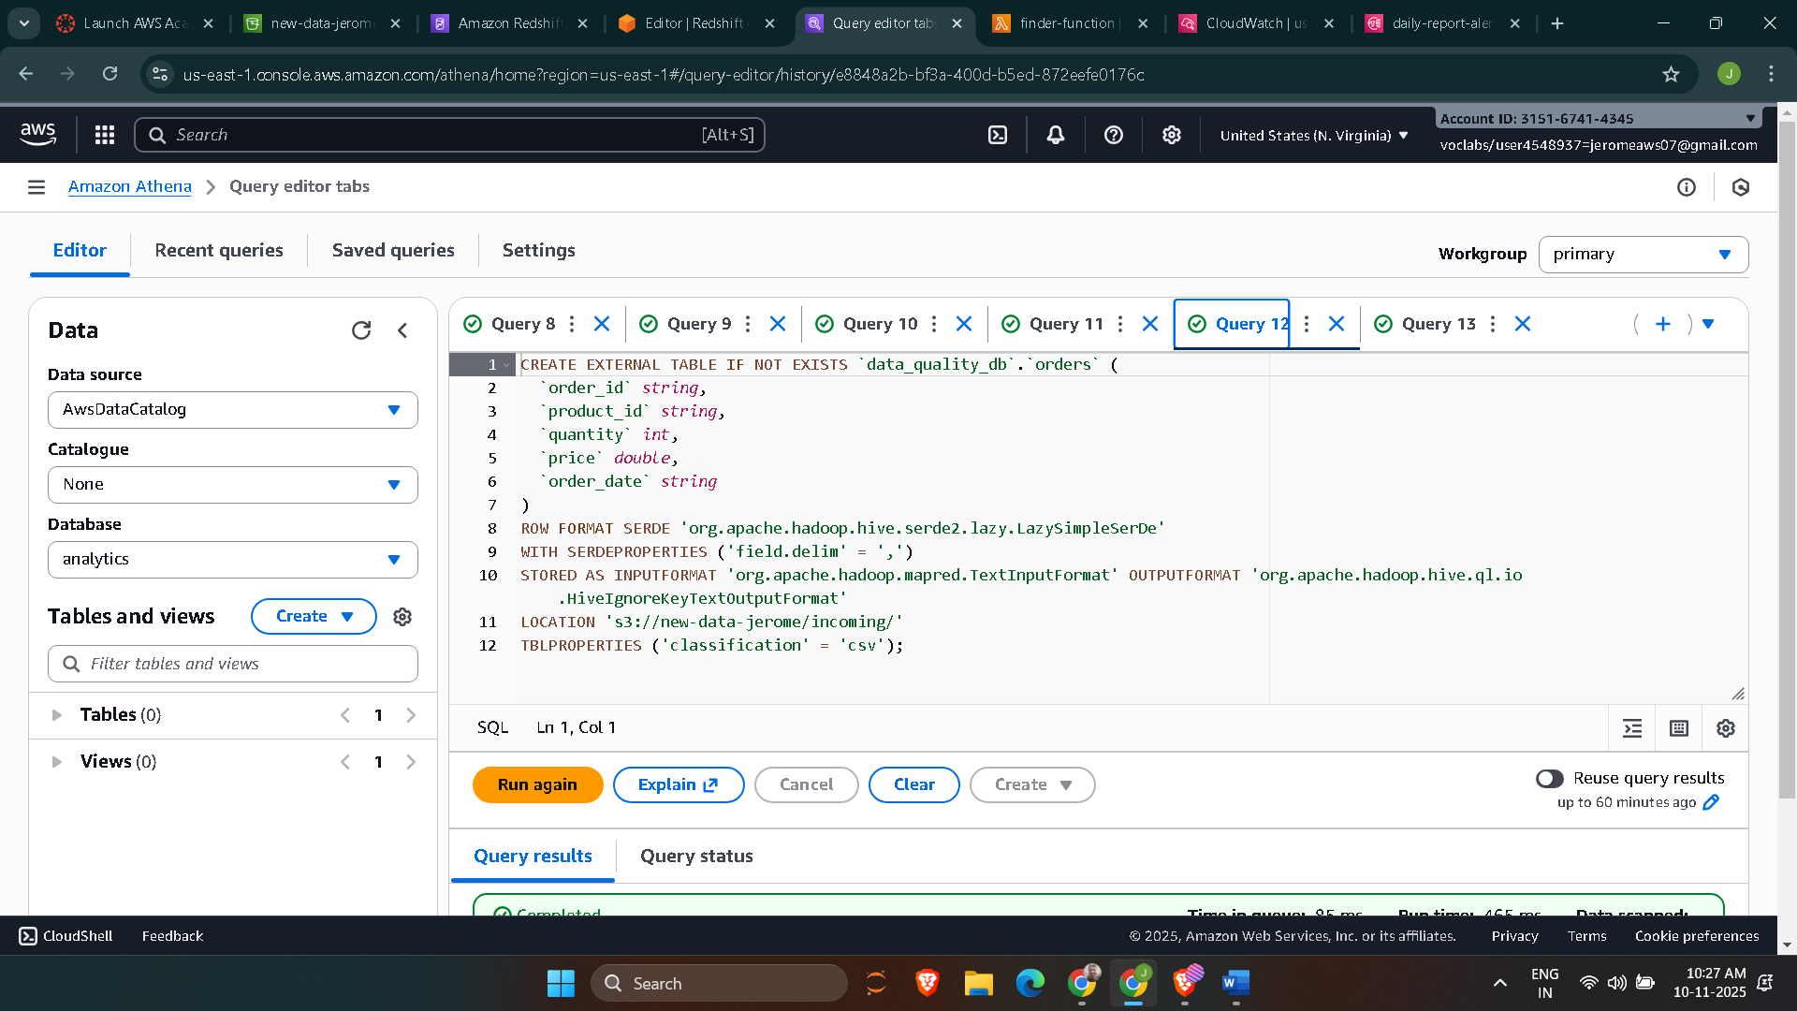

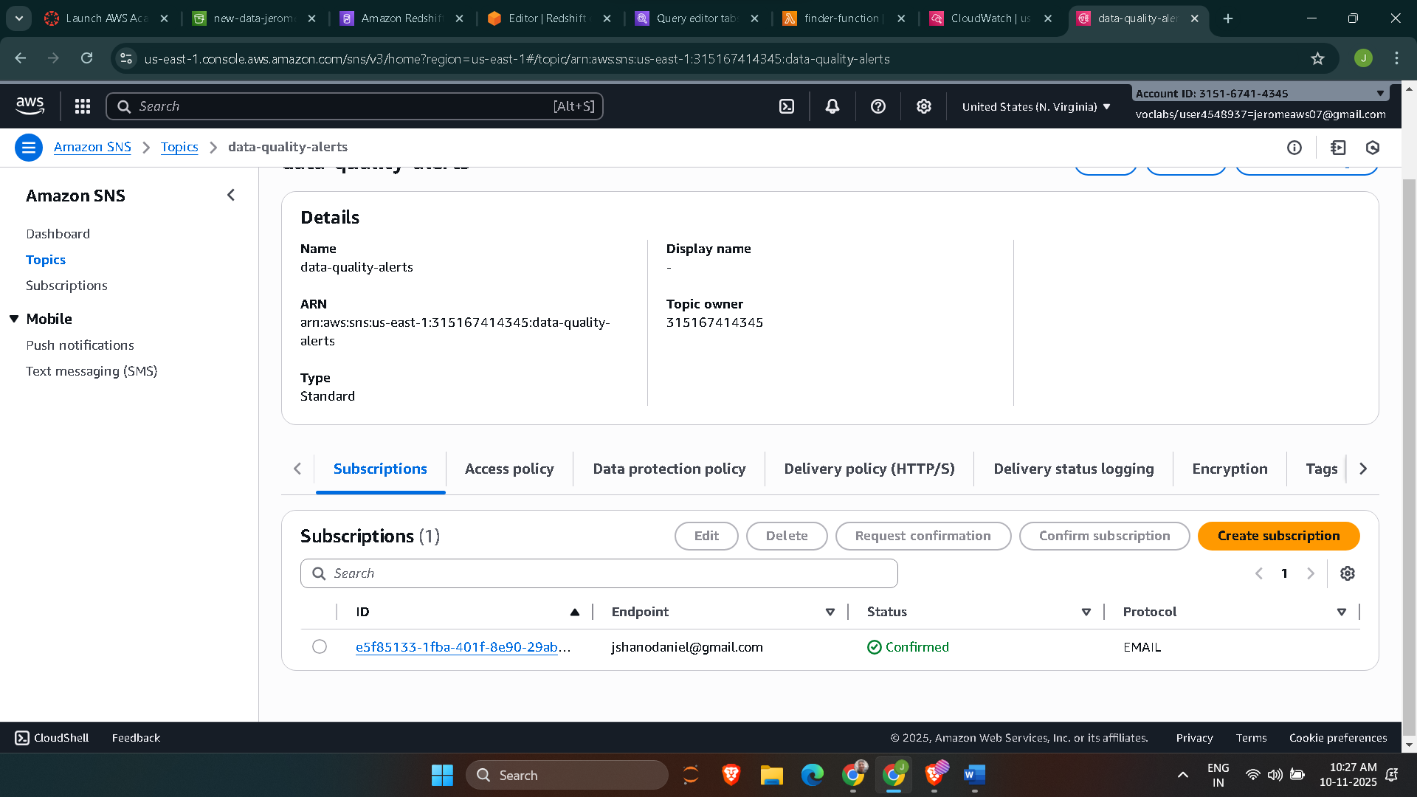

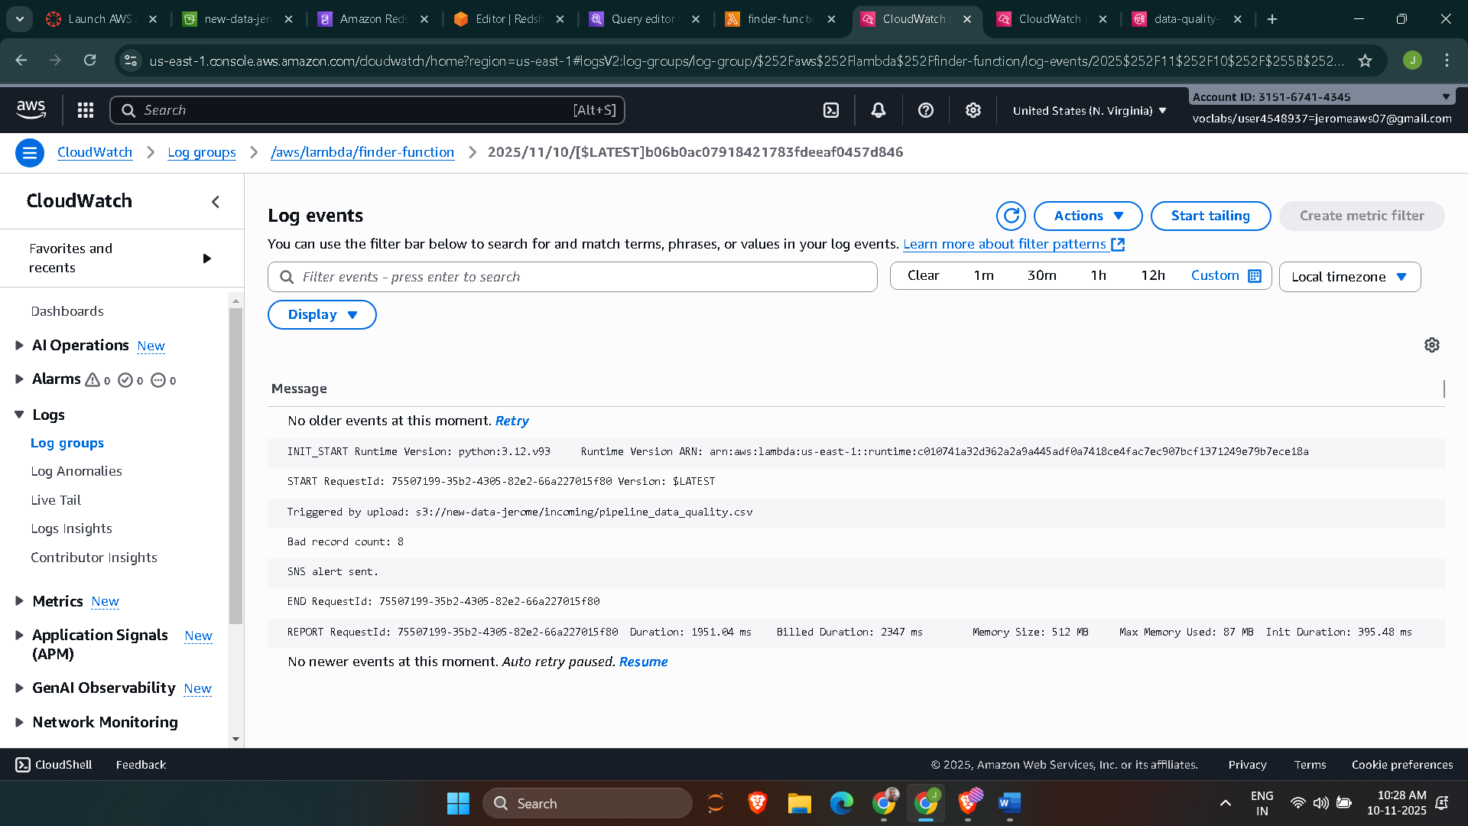

Question-4
